User Guide
Requirements :
- Install Xampp and ensure it is working : https://youtu.be/7qVP5de7hAY?si=YFQ172o5o9FxqYcj or just search ‘Installing Xampp” on YouTube
- Ensure the PC has ‘Python’ and other required libraries and modules
  - Verify python using python --version
  - Install all the required libraries using pip: pip install pandas mysql-connector-python flask sqlalchemy flask-cors openpyxl xlsxwriter (if any extra library is required then use the same format: pip install library_name )
Template preparation:
- There is a template (specific format) to upload data to the system.
- The template exists as excel workbook which can consist of multiple sheets (indicating multiple tables) (workbook=database, sheet=table)
- Each sheet consists of data presented in the form of rows and columns.
The column name in each sheet should only be in 1st row only (no merging of rows)
- 1st column in the sheet is primary key that uniquely identifies each row. It should be present in every sheet in same format . The sheets will be joined on the basis of this primary key
- In the current experimental scenario the primary key is formed by combining the content of column-2 to column-5 (4 columns) because these 4 columns are sufficient to uniquely identify each row in provided data (The number can change according to the type of data).
- One can adjust the ‘number of columns to combine’ to form the primary key by removing or adding them.
- When a column gets added/removed to form primary key – just ensure the formula to form that primary key in the excel sheet (=TEXTJOIN("-",TRUE, E2,B2,C2,D2) in current case ) is also adjusted. The primary key will automatically be created when we add data in the selected columns.
- Please provide proper name to each column and each sheet and do not merge any row/column.
We just have to normalize the data in the template and the rest will be handeled

In given tables ID is the primary key
ISE1 :
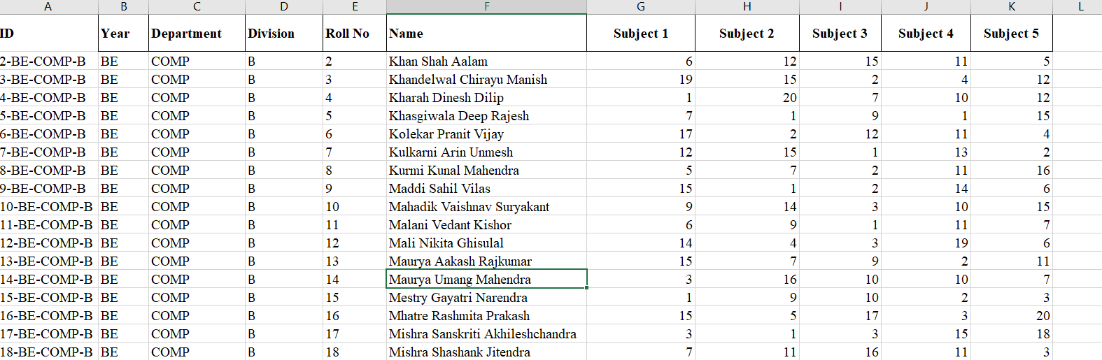
Teacher_guardian:
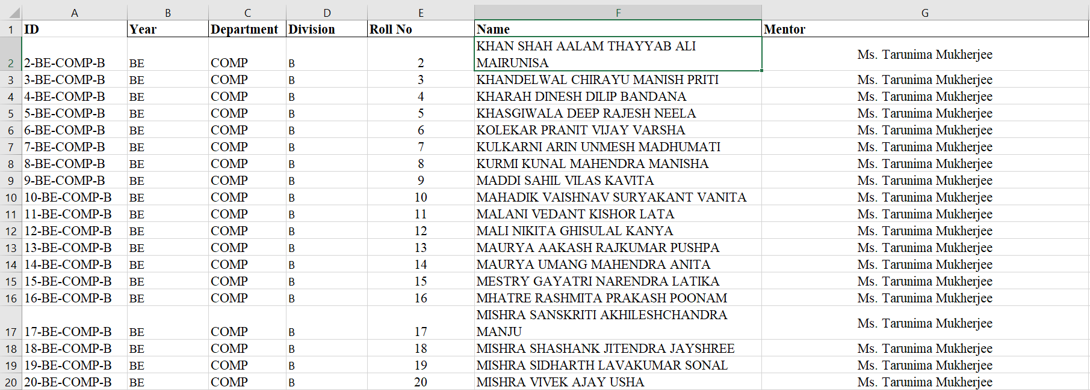

Steps to use:
- Open Xampp control panel. Start ‘Apache’ and ‘MySQL’ in the Xampp control panel.
- Open the project folder with VS code.
- Open a new terminal and run the server using the command: python server/app.py
- Right-click on index.html and open it with live server
- Upload the template file and give an appropriate name to the database
- Apply appropriate filters on the filter.html page and click on ‘submit’ . We can also ‘reset’ the filters. If no filters are applied, then the tables will simply join.
- Until our database is not deleted, we can refresh the filter.html page as many times as we want. When we click on the ‘submit’ button, the filtered and joined data will be downloaded on our local device in the form of an Excel file with name ‘filtered_data’.
- When the data will be downloaded, we can either reset and apply other filters or we can click on the ‘drop and exit’ button.
- When we click on the ‘drop and exit’ button, the database will be deleted and will be redirected to the ‘Thankyou Page’

